Understanding and Explaining Hydro-Climate Variations at Devils Lake

A NOAA Climate Assessment

July 2010

Understanding and Explaining Hydro-Climate Variations at Devils Lake

By Martin Hoerling, Jon Eischeid, David Easterling, Thomas Peterson, Robert Webb

Prepared in support of the Interagency Initiative to Address Flooding Issues at Devils Lake, ND

National Oceanic and Atmospheric Administration

Forward

This assessment of the climate conditions relevant to the recent rise of Devils Lake elevation is part of the NOAA response in support of the Interagency Initiative to Address Flooding Issues at Devils Lake, North Dakota. It focuses NOAA’s climate expertise to understand and explain Devils Lake current and past variations in precipitation, and relate those conditions to Devils Lake volume variability.
The effort includes climate experts from NOAA’s Earth System Research Laboratory and the National Climate Data Center. The task team has assessed current knowledge of the variability of Devils Lake elevation based on prior USGS reports, primary source literature, and placed those into a context of the current understanding of historical climate variability over the region. This report also assesses current understanding of anthropogenic climate change impacts in the region of Devils Lake, North Dakota based on the recent publications of the Intergovernmental Panels on Climate Change, and the U.S. Global Change Research Program. The report also presents considerable new analysis of weather and climate data in order to bring the assessment up to the most recent conditions, through 2009.

Executive Summary

The period 1990-2009 ranks as the wettest 20-yr period in the Devils Lake Basin since 1895. The annual fluctuations in Devils Lake elevation strongly correlate with decadal averages of precipitation falling over the basin during the century-long record of instrumented hydrological and meteorological observations. It is therefore very likely that the record elevation of Devils Lake occurring in 2010 is primarily a consequence of a multi-decade wet period over the lake’s drainage basin.

The recent wet epoch over Devils Lake is comprised of two meteorological patterns in time and space. One is a national-scale trend pattern toward increased precipitation that emerged in the late 1960s, replacing what had been prolonged dryness for much of the first half of the 20th Century. Another is linked to a regional pattern of wetness concentrated within a narrow Great Plains corridor running from the Texas panhandle northward to southern Manitoba and Saskatchewan. Its temporal attributes are unlike the national-scale trend pattern, being instead dominated by abrupt swings between dry and wet epochs having decadal duration. The recent wet epoch within this Great Plains corridor, in which Devils Lake has been a virtual epicenter, began in 1992 coinciding with the period of rapid and dramatic rise in Devils Lake elevation.

Several lines of evidence lead to an assessment that the current wet epoch over Devils Lake basin, and the resulting record lake elevation, are mostly part of a natural cycle of hydro-climate variability. Paleoecological studies of Devils Lake reveal dramatic and rapid shifts between high and low Devils Lake elevation for much of the period since the lake’s ice age birth that are strikingly similar to recent events. Further, much of the recent observed wetness over Devils Lake is tied to a regional pattern of enhanced rainfall stretching from the southern U.S. Plains to the Canadian Prairie. The characteristic time history of this pattern is one of roughly decade-long variations, and appears not to be symptomatic of a fundamental change in the region’s rainfall due to greenhouse gas effects. This pattern is quite different from the continental-scale pattern of precipitation increase over the entire northern U.S. and Canada that is expected to occur as a consequence of further increases in greenhouse gas concentrations. The recent extreme wet conditions thus are likely transitory in nature. No formal detection study has been undertaken to address whether a human-induced change in precipitation has occurred. It is noted, however, that most of the increase in annual rainfall since 1980 over Devils Lake has resulted from heavy downpours, a feature that may be indirectly related to human activities.

Current projections of how human-induced climate change will affect North American hydrologic conditions by the mid-21st Century indicates virtually no change in annual runoff over the Devils Lake region. In this regard, it is likely that Devils Lake elevation will continue to fluctuate in concert with strong natural decadal variations of precipitation that typifies the climatic history of the western Great Plains region.

- Historical Attributes of Devils Lake

Devils Lake is located in northeastern North Dakota at 48°2’N, 98°56’W. The area of the lake, and the adjacent city that bears its name, were originally Mni Wakan Dakota
lands. The native inhabitants named the lake “spirit water,” which the early explorers translated into Devils Lake because of the legends of drowned warriors. The lake itself resides atop the Spiritwood Acquifer, which, according to the U.S. Geologic Survey (USGS; Wiche et al. 2000), stores about 1 million acre feet of ground water in the Devils Lake area. This compares to a similar volume of lake water when its elevation is near the historical average height of 1430 feet (above mean sea level).

During higher than normal water levels, Devils Lake greatly expands in area causing widespread flooding of private lands. Inundation of adjacent agricultural land, in addition to causing an immediate crop loss, threatens the longer-term fertility of those lands due to the flood water salinity. Adjacent water bodies (e.g. Stump Lake) are also affected during Devil Lake flooding when the lake level exceeds 1446.5 feet. Above an elevation of 1458 feet (the elevation was 1459 feet, but the State Water Commission permitted removal of 1 foot of material from a road like crossing that was at an elevation of 1459 feet), Devils Lake (and Stump Lake) spill into the Sheyenne River releasing an uncontrolled torrent that potentially yields significant negative consequences for the town of Devils Lake and downstream communities. It is only at this highwater level that Devils Lake contributes to the Red River Basin (and spills into the Sheyenne River). According to data collected by the USGS (Vecchia 2008), Devils Lake has been below this critical elevation threshold since at least 1868 when instrumental measurements of lake elevation first became available.

Devils Lake is of glacial origins, and the fact that it is a closed lake has allowed meaningful paleoclimatological studies using proxy information to estimate elevation changes several thousand years before the present time. These reconstructions (Bluemle, 1991; Murphy et al., 1997).reveal numerous cycles between high and low water levels that have been interpreted to indicate wet and dry cycles over the northern Great Plains (Fig. 1)

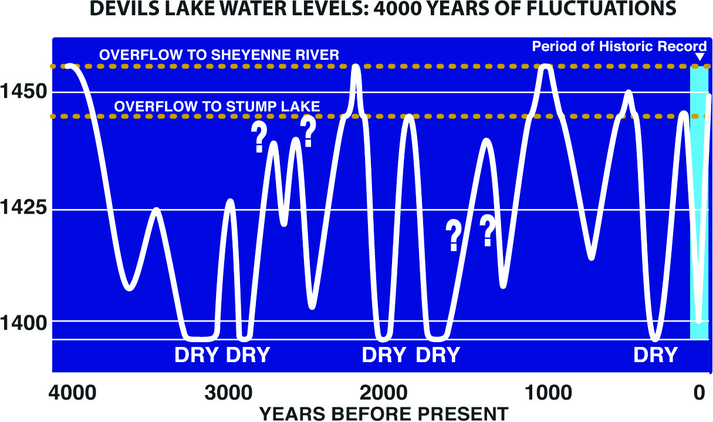

Figure 1. Devils Lake water levels based on paleoecological studies of sediment deposits in the lake bed (Bluemle, 1991; Murphy et al., 1997). Low (high) water levels are inferred to correspond to dry (wet) climate conditions. Direct measurements have been taken during the period shown in light blue. The current strong centennial rise in water levels detected by gage measurements is commensurate with historical fluctuations. Graphics Source: North Dakota State Water Commission Fact Sheet, available at http://swc.state.nd.us/4dlink9/4dcgi/GetContentPDF/PB-206/DLFactSheet2010.pdf)

- Annual Precipitation and Lake Elevation Co-Variations since 1900

Meteorological conditions and Devils Lake elevation have been monitored directly with instrumentation during the last century, and the data collected by the USGS and NOAA reveal distinct decade-long fluctuations in both precipitation falling over the lake’s drainage basin and in the lake level. The variations are not unlike those inferred from paleorecords of the last 4000 years, and thus appear to reside within the range of centennial fluctuations that characterize the hydro-climate of the area. Since 1900, the annual time series of Devils Lake elevation shows sustained periods of fall and rise (Figure 2, solid blue curve). A 40-yr decline took place from 1900 until the early 1940s culminating in a minimum elevation of about 1400 feet. The lake level has since risen in step-like manner with three periods of rapid rise---the first occurring during the early 1940s till the late-‘50s, the second from the late 1960s till the mid-‘80s, and most recently from the early 1990s till present.

Why has Devils Lake risen in the last half-century? The rise, although abrupt in speed and dramatic in scale when viewed through the lens of the short instrumental record, is itself not unusual---such sharp rises in Devils Lake embodies a characteristic behavior which paleo evidence suggests has occurred over the several millennia since the lake’s ice-age birth. That fact in no way diminishes the importance of understanding the cause for the recent rise since a clear explanation could provide insight on the likelihood of the lake achieving the critical 1459 foot spillage elevation in the foreseeable future. A particular question is how the lake’s rise relates to recent patterns of precipitation, and whether emerging human-induced changes in climate are contributing to the recent lake rise. Other factors, such as changes in land use and new agricultural practices (including irrigation) may also play a unique role in the recent century compared to the paleo-record, though these will not be addressed in the current assessment.

Figure 2 also plots the observed annual precipitation departures area averaged over Devils Lake drainage (bars) together with a smoothed (black) curve to highlight its decadal and longer time-scale variations. The protracted decline in lake elevation in the early part of the 20th Century clearly occurred in concert with a drying trend, one that culminated in the extremely dry 1930s and the Dust Bowl era. Likewise, the lake level surge during the most recent 20 years occurs during a pronounced wet epoch, a period that is the wettest 20-year average over Devils Lake since at least 1895 when

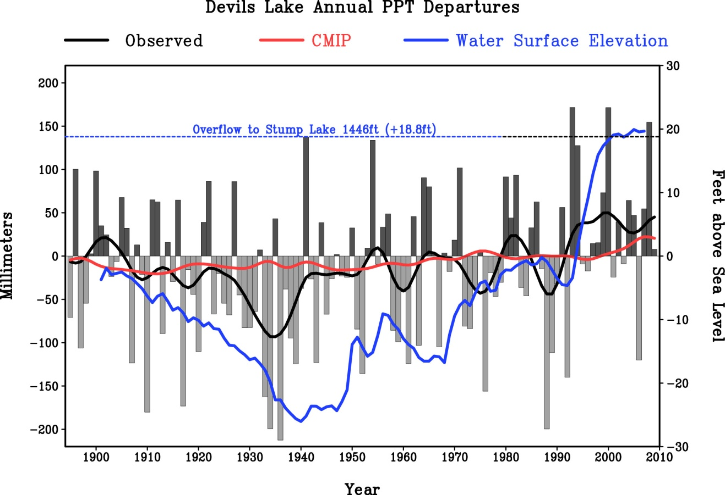
Figure 2. The annual departures in observed precipitation (gray, vertical bars) during 1895-2009 and annual departures in Devils Lake elevation (blue curve). Black curve is a smoothed version of the annual observed precipitation using a 13-point Gaussian filter applied to raw annual values which retains periods greater than 10 years. Red curve is the smoothed annual precipitation time series from an ensemble average of 22 climate simulations forced by the time evolving greenhouse gas and aerosol fluctuations. Precipitation is for an area-average approximating the Devils Lake drainage. The observed data are from station measurements gridded to high spatial resolution (Chen et al., 2008). The model data is from the Intergovernmental Panel on Climate Change Fourth Assessment (IPCC 2007) suite of 22 different models. Devils Lake elevation data is for 1900-2007 supplied by USGS. Departures are relative to a 30-year reference of 1971-2000. PPT denotes precipitation, and CMIP denote the Coupled Model Intercomparison Project.

instrumented observations became available for the region. For the century-long record as a whole, there exists a positive correlation of +0.71 between annual precipitation and annual Devils Lake elevation attesting to the strong temporal coherence between climate and hydrology over the region.

The mechanisms by which Devils Lake elevation fluctuates are undoubtedly more complex than can be described by such simple linear correlations with annual precipitation alone. For instance, the dynamics of surface and groundwater flows are an important aspect of the hydrologic response of a basin, and it is reasonable to expect some degree of temporal lag between runoff production and lake volume change. Figure 3 shows schematically the processes maintaining Devils Lake volume, including the principal pathways for water at and below the surface. Surface runoff-induced inflow, groundwater flow, variations in height of the groundwater table that intersects the lake bed, and the loss of water by evapotranspiration are all factors to consider in addition to the precipitation that falls directly over the lake.

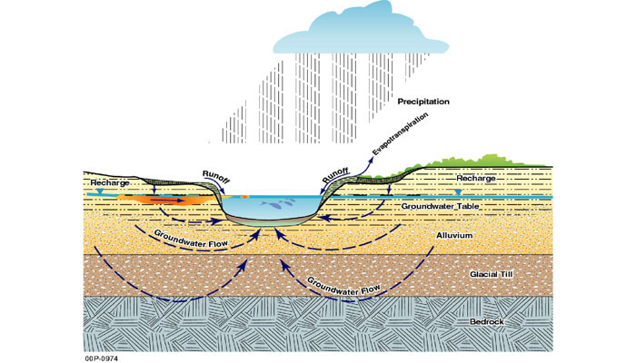
Figure 3. Schematic diagram of the hydroclimatic factors maintaining water volume within a closed lake.

Surface runoff is a major source of water to Devils Lake. During the spring season in particular, the combination of melting snow fields and cool season rains falling on mostly frozen grounds act to swell the narrow, braided channels and creeks (called coulees) that draw water into the lake from the overall drainage basin. Devils Lake surface area, at an elevation of about 1450 feet is approximately 600km². By contrast, the area of the drainage basin is nearly 20-fold greater at about 9800km² (e.g., Wiche et al. 2000). Thus, an even modest surplus of surface water generated at the basin-wide scale would induce a disproportionately larger response in lake water volume. This is indeed the typical characteristic of the seasonally varying change in Devils Lake volume which experiences a sudden and dramatic rise during spring in response to the aforementioned surface runoff sources (Figure 4).

Groundwater flow and fluctuations in the height of the water table likely also play roles in fluctuations in lake elevation, and it is reasonable that these would occur on a longer time scale than associated with surface-based runoff. However, the scientific arguments on the importance of groundwater dynamics are not of a kind to be resolved by the available observations at this time. An accumulation of new data that describes the hydraulic conductivity and diffusivity of water thru the aquifer of the Devils Lake basin would be important to assess the efficiency and the time scale by which the infiltration of surface water eventually affects lake level via water movement through soils, sediments, and rock.
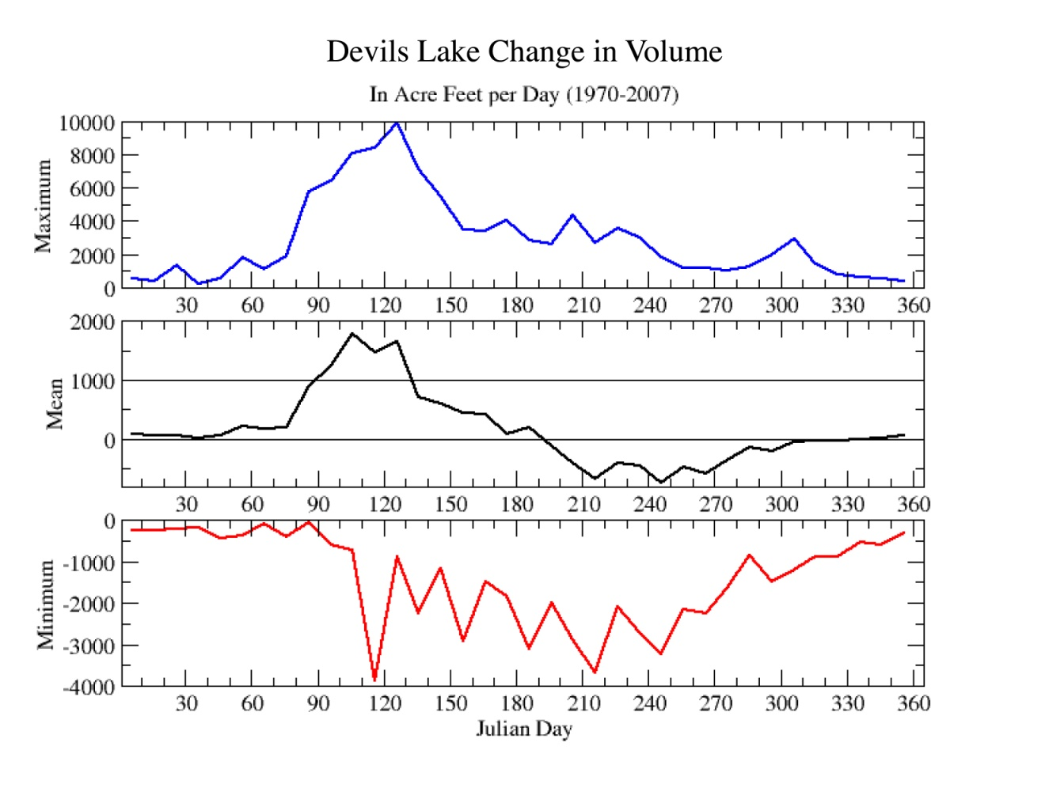Figure 4. The 10-day changes in Devils Lake level volume during 1970-2007 plotted in acre feet/day (ordinate). Abscissa is the Julian day, beginning in January on the left hand side. The middle graph (black contour) depicts the mean fluctuation in lake volume, whereas the top (bottom) curves show the maximum rates of rise (fall) in lake volumes. The mean lake level is flat during the winter, increases from March (Julian day 60) through early June and then decreases in summer and fall. Analysis is based on daily USGS measurements of Devils Lake volume since 1970. Data source for daily lake level data is http://nd.water.usgs.gov/devilslake/dvlake.txt, and data source for the conversion table of lake level to lake volume is http://nd.water.usgs.gov/devilslake/elevation-area-volume.xls

- Seasonality of Precipitation and its Variations over the Devils Lake Basin

To gain a deeper physical understanding of the climatic influences on Devils Lake, and in particular to better understand reasons for its dramatic rise post-1993, it is useful to analyze the seasonal delivery of precipitation. Devils Lake resides in a climate zone referred to as temperate/humid continental according to the Koeppen climate classification. Its attributes are warm summers and cold winters, with a summer season maximum in precipitation. June and July are the months of maximum rainfall (Figure 5, top), while January and February are the basin’s driest months. A very different picture emerges for the precipitation efficiency, measured as the difference between precipitation and evapotranspiration. The latter, which has been derived from monthly measurements of surface temperature using the Thornthwaite formula (Thornthwaite 1948), exhibits the greatest evaporative loss in July and August when peak temperatures occur. It is the joint seasonal cycles of moisture gain by precipitation and its loss by evapotranspiration that determines the capacity for producing surface runoff. The P-E seasonal cycle (Figure 5, lower panel) uncovers several key features of this region’s surface water budget. Foremost is the near-balance between precipitation and evaporation when averaged over the entire year, with a cold season surplus and a warm season deficit. Although the annual P-E balance implies little annual mean runoff production under climatologically normal conditions, this is not to imply that a portion of precipitation does not swell creeks during some portion of the year (for instance, in heavy rain storms), or infiltrate and contribute to sub-surface flows. The evidence for strong seasonality in the ability of the basin to generate runoff-driven water for the lake has already been shown in Fig. 4, and it is interesting to note that the months of most rapid monthly rise in Devils Lake volume (March and April) are among the drier months of the year. Clearly, the efficiency of surface runoff production in early spring combined with the usual snowpack source of surface water are both important to the seasonal rise in Devils Lake. In the same manner, the excess of evapotranspiration over precipitation in summer is key in understanding the seasonal decline in Devils Lake from summer thru fall.

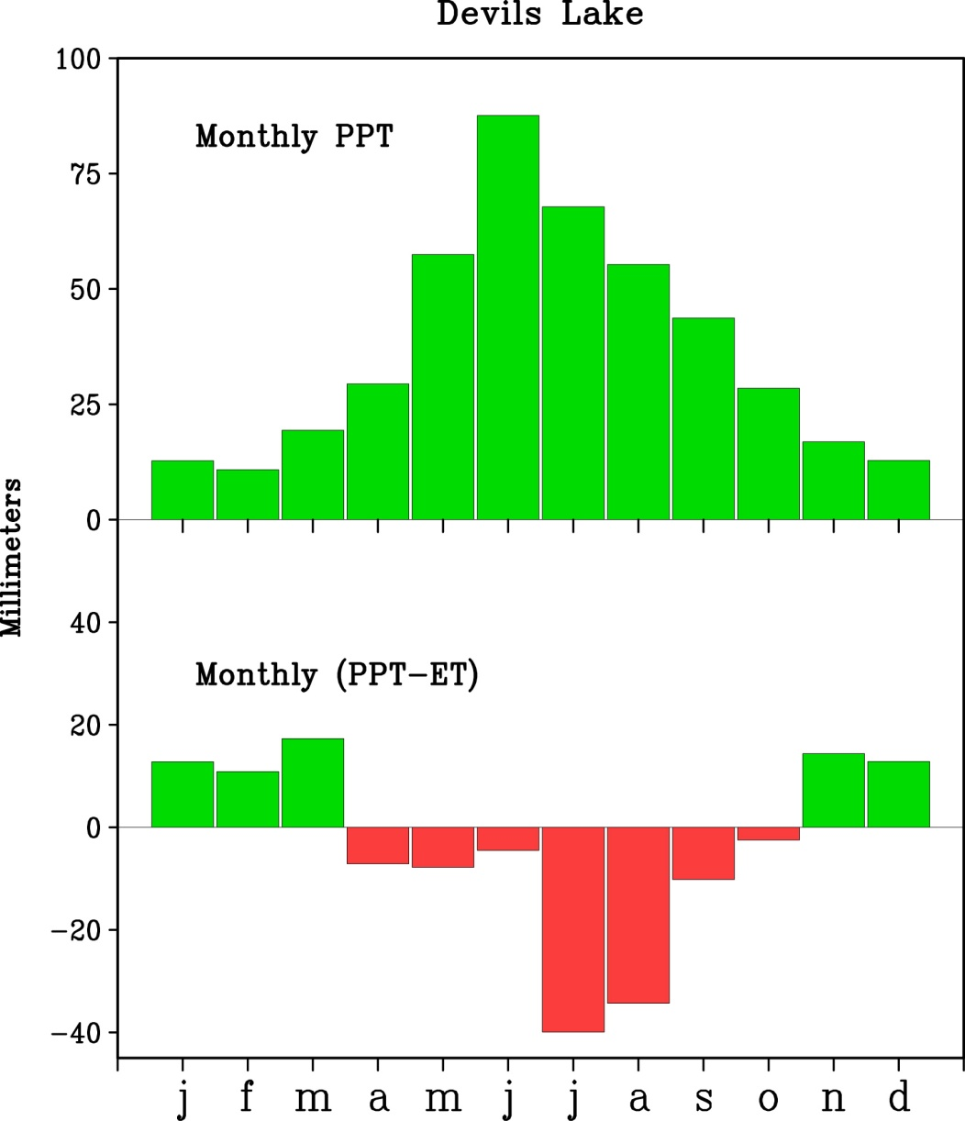
Figure 5. The observed monthly climatology of precipitation (top, mm), and precipitation minus evapotranspiration (bottom, mm) averaged over the Devils Lake drainage basin. The observed precipitation data are from station measurements gridded to high spatial resolution (Chen et al. 2008). Evapotranspiration has been derived from from station measurements of surface temperature also gridded to high spatial resolution, and employs a Thornthwaite (1948) formulation. The climatological period is 1971-2000. PPT denotes precipitation, and ET denotes evapotranspiration.

Despite the normal abundance of summer rains over Devils Lake, these are largely consumed by evaporative demand. It is the winter and spring precipitation that is most effective in generating runoff. One implication is that Devils Lake would be especially sensitive to surpluses in cold season precipitation owing to its high efficiency, whereas disproportionately greater summer rainfall anomalies would be required to render a similar impact on runoff. These sensitivities are noticeable from inspection of the co-variability of Devils Lake elevations with cold season precipitation (Figure 6, top) and warm-season precipitation (Figure 6, bottom). For instance, the sudden rise in lake levels after the Dust Bowl era during the 1940s is clearly linked to a sequence of wet winter conditions, and this recovery occurred despite ongoing deficits in summer rainfall. Likewise, a decade-long decline in Devils Lake that commenced after 1956 occurs in tandem with a string of consecutive dry winters that was virtually unbroken until the late 1960s, while summer rains were more variable. In contrast, the more recent conditions after 1993 paint a picture of coordinated summer and winter precipitation surpluses that each have likely contributed to lake level rise. The sudden rise in Devils Lake near and just after 1993 occurs in concert with the wettest warm season rain total on record (1895-2009) in 1993. The +200mm surplus that summer was nearly three-fold greater than the amplitude of standard summer seasonal rainfall variability, and was more than sufficient to overcome the typical excess in evaporative demand (see Figure 5). Then, beginning in 1995, six consecutive wet winters occurred, the longest consecutive such string on record. This in turn was followed by a sequence of seven consecutive wet summers beginning in 1999, and most recently culminated in the wettest winter on record in 2008-09. The +120mm surplus that winter was also nearly three-fold greater than the amplitude of standard winter seasonal precipitation variability. This wet gauntlet of meteorological conditions since 1993 has clearly yielded the current state where Devils Lake threatens to spill its banks into the Sheyenne River.

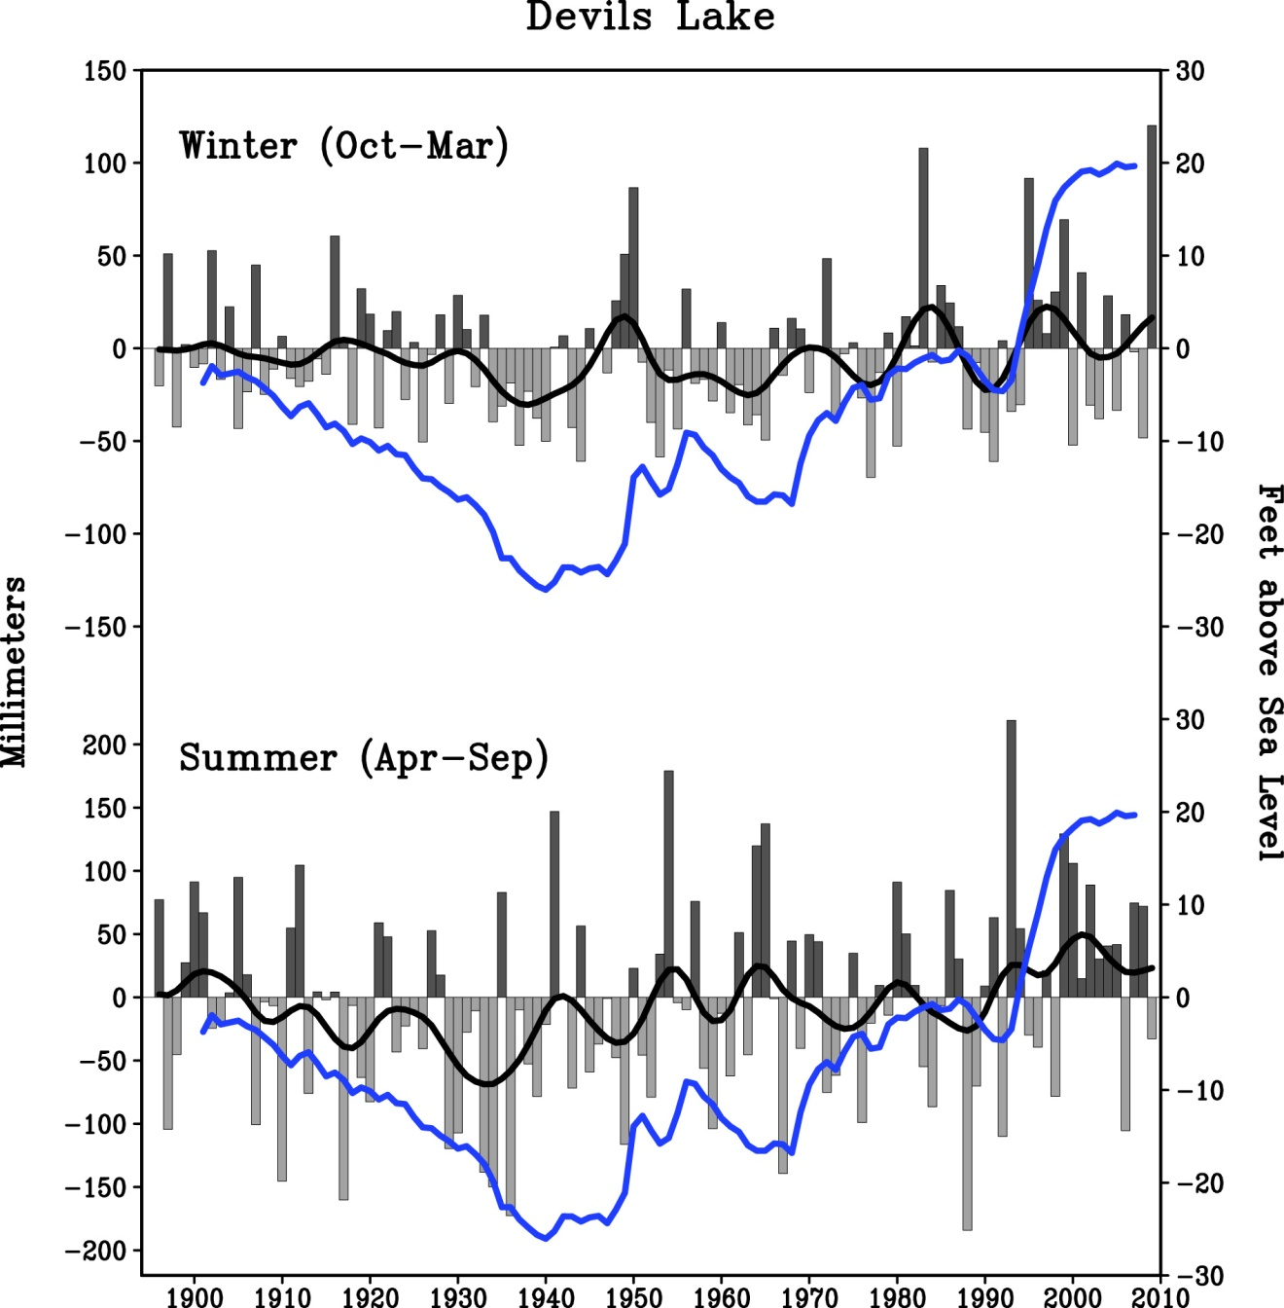

Figure 6. Seasonal departures in observed precipitation (gray, vertical bars) during 1895-2009 and annual departures in Devils Lake elevation (blue curve). Top panel is for the cold season, and lower panel is for the warm season. Black curve is a smoothed version of the seasonal observed precipitation using a 13-point Gaussian filter applied to raw seasonal values which retains periods greater than 10 years. Precipitation is for an area-average approximating the Devils Lake drainage. The observed data are from station measurements gridded to high spatial resolution (Chen et al 2008). Devils Lake elevation data is for 1900-2007 supplied by USGS. Departures are relative to a 30-year reference of 1971-2000. Note the different left side vertical scale for summer versus winter precipitation.

- A National Context of Devils Lake Precipitation Variability

Placing the variability of Devils Lake precipitation into a context of continental-scale variations elucidates plausible causes for the recent lake volume rise. A standard method to determine the most important patterns of variability is to conduct an Empirical Orthogonal Function (EOF) analysis, a process of decomposition of the data into an ordered set of independent patterns that explain the temporal variability of the data set over the period of record. Such an analysis finds both time series and spatial patterns that describe how the data vary. An EOF decomposition applied to annual observed precipitation data (Schneider et al. 2008) for North America reveals two patterns of variability which, when combined, explain most of the variability in annual precipitation over the region of Devils Lake since 1900. The first pattern (which is the second leading pattern for describing variability over the entire continent¹) describes a wet (or dry) condition having national-scale, but with particularly strong amplitude over the northern

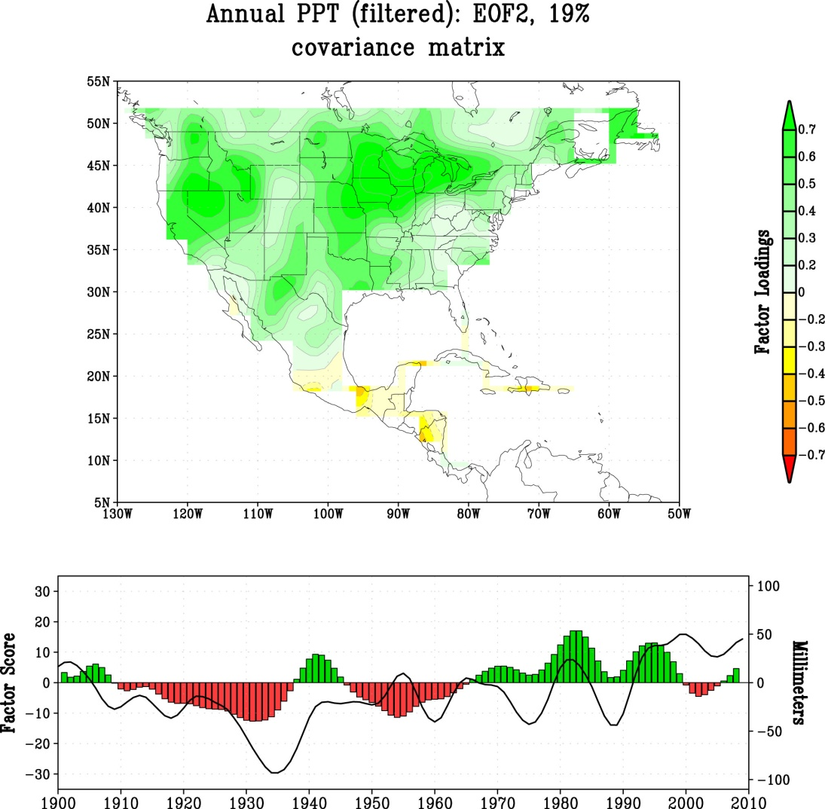

Figure 7. The statistical pattern of observed annual precipitation variability using the method of Empirical Orthogonal Function (EOF) analysis. The spatial plot shows the second leading pattern of precipitation variability for North America as a whole. This pattern is shown because it is one of two dominant national patterns, with strong amplitude over the Great Plains region. The time series is this empirical pattern is shown in the lower panel. The superimposed black contour is the smoothed annual precipitation time series averaged over Devils Lake. PPT denotes precipitation. Data available at http://www.esrl.noaa.gov/psd/data/gridded/data.gpcc.html.

1____________________
The leading EOF of North American annual precipitation variability describes a pattern of mainly Canadian precipitation variability, the time series of which is noteworthy for a trend toward wetter Canadian conditions over the period of record.
Plains and Midwest. (Fig. 7, top). The time evolution of this pattern (Figure 7, bottom) depicts a trend resulting from the preponderance of national-scale drought during the 1930s and 1950s and wet conditions after 1970. When the temporal variations of this pattern is compared to the time series of Devils Lake precipitation (black, solid curve), one can infer that Devils Lake variability was entwined with a national-scale of drought during the first half of the 20th Century, but that the recent wet conditions have not been part of a national-scale pattern.

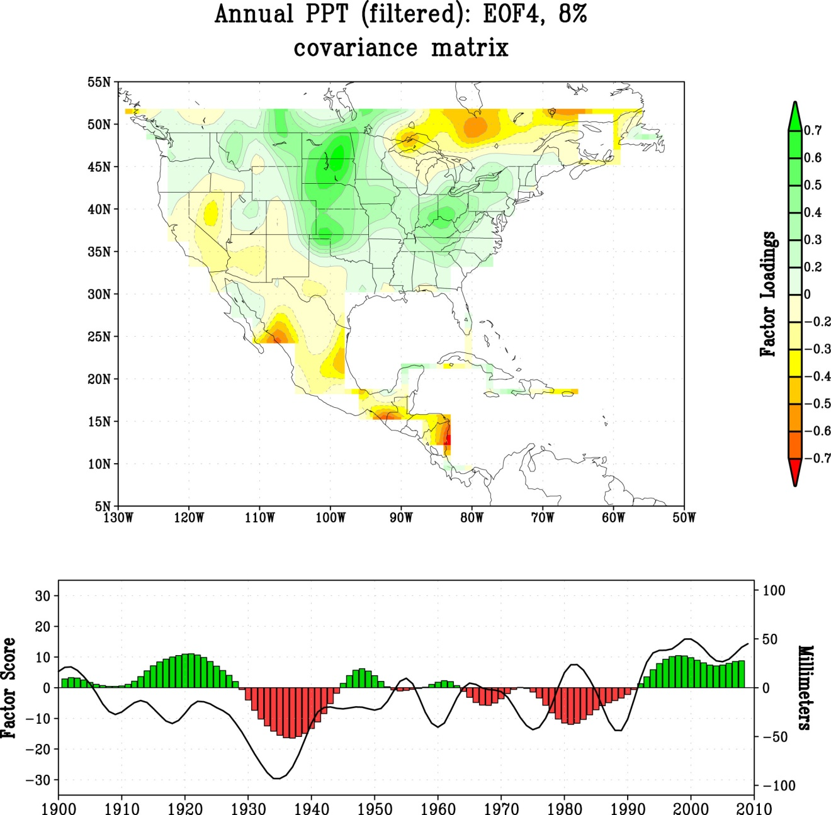

Figure 8. The statistical pattern of observed annual precipitation variability using the method of Empirical Orthogonal Function (EOF) analysis. The spatial plot shows the fourth leading pattern of precipitation variability for North America as a whole. This pattern is shown because it is one of two dominant national patterns, with strong amplitude over the Great Plains region. The time series of this empirical pattern is shown in the lower panel. The superimposed black contour is the smoothed annual precipitation time series averaged over Devils Lake. PPT denotes precipitation. Data available at http://www.esrl.noaa.gov/psd/data/gridded/data.gpcc.html.

The second pattern has a distinct regional expression over the northern Plains region (Figure 8). In its positive phase, it describes a band of increased annual precipitation over a corridor of the western Great Plains from the Texas panhandle to southern Manitoba and Saskatchewan with a center of maximum amplitude over the Dakotas. The time series of this pattern is characterized by decadal variability, rather than a trend as typified by the other EOF. Furthermore, this pattern captures the wetness over Devils Lake in the 21st century period.

- Reconciling Hydrologic Conditions with Anthropogenic Climate Change

To what extent are the wet hydrologic conditions over the Devils Lake basin since 1990 reconcilable with the region’s sensitivity to greenhouse gas and anthropogenic aerosol forcing? There are several aspects of the anticipated impact of anthropogenic climate change that could affect Devils Lake elevation. One is via an anticipated warming of surface temperatures which would increase potential evapotranspiration and thereby reduce surface water availability². A second is via a change in mean precipitation, for which an increase is anticipated in the latter half of the 21st century (IPCC 2007). And a third is via a change in the character of precipitation, with an expectation for an increase in the amount of daily precipitation falling in heavy events for the U.S. as a whole (CCSP 2008) which would be expected to increase runoff.

As part of the Fourth Assessment of the Intergovernmental Panels on Climate Change (IPCC), global climate models were forced by the known changes in greenhouse gases and aerosols for the 20th Century, and then forced by emissions scenarios of greenhouse gases through the end of the 21st Century. The red curve in Fig. 2 plots the time series of annual precipitation simulated for the region of Devils Lake based on the average of 22 different IPCC models, using the so-called Climate Model Intercomparison Project (CMIP-3) data set. The curve reveals a small increase in precipitation after 2000 owing to greenhouse gas forcing. The muted variability in this CMIP simulated time series is mostly a consequence of the ensemble averaging process which seeks to identify the coherent influence of external forcing by greenhouse gases, aerosols, solar and volcanic forcing, isolating it from natural internal sources of variability. Individual model simulations have greater interannual and decadal variability, and observed 1900-2009 variability falls within the range simulated by individual models (result not shown). It is clear that the weak signal of external forcing according to the multi-model ensemble pales in magnitude to the increase in annual precipitation that has occurred after 1990.

²_____________________
The 20-year average surface temperature for 1990-2009 was compared to the prior 1961-90 period to assess recent trends during the period of heavy precipitation and rapid lake level rise. There has been no appreciable change in warm season (April-September) temperatures over the Devils Lake basin, when evaporation would be most sensitive to temperature change. There has been significant warming of about +1°C in the cold season, when evaporation is least sensitive to temperature change (figures not shown).

While the observed increase in annually averaged precipitation in recent decades cannot be reconciled with an anthropogenic signal alone, the recent several decades have witnessed a distinct change in the character of daily precipitation events over the Devils Lake drainage basin. Figure 9 compares the contribution of daily precipitation events to annually averaged anomalies for two 30-year periods: the relatively dry 1948-77 epoch and the relatively wet 1980-2009 epoch. The curves (top) show the cumulative precipitation anomalies across the various percentiles of daily precipitation intensity, beginning with weak events on the graph’s left side and accumulated thru the most intense events on the graphs right side. It is evident that the positive annually averaged departure of about +30mm during 1980-2009 (relative to the 1948-2009 reference) is almost entirely attributable to the upper 80 percentile of daily events. Also, daily rainfall events have increased in frequency in the past 30-yrs over all intensity categories (bottom), with the greatest increase in frequency occurring for the moderate intensity (50th percentile) events. Since 1980, Devils Lake has experienced a higher proportion of annual rainfall from heavy precipitation events compared to the prior 30-yr period, a situation observed over many areas of North America in recent decades (see report on Global Climate Change Impacts in the United States 2009). It is unclear how important a factor the changing character of daily events has been for Devils Lake elevation increase.

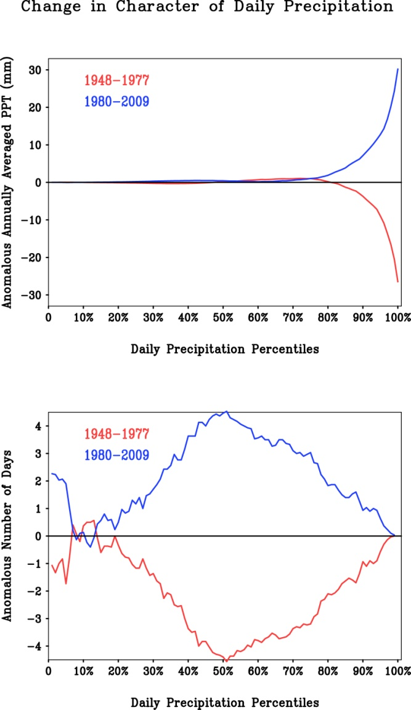
Figure 9. An assessment of the change in character of daily precipitation over the Devils Lake drainage basin. Top panel shows the contribution of daily precipitation to the change in annual precipitation over the Devils Lake drainage basin for 1980-2009 (blue curve) and 1948-1977 (red curve). Curves are the precipitation departures cumulative across the daily precipitation percentiles, ranging from weak daily events (left side) to heavy daily events (right side). Precipitation anomalies are relative to the 1948-2009 climatology. Bottom panel shows the change in number of rain days across the daily precipitation percentile, from weak daily events (left) and heavy daily events (right). The daily precipitation data is based on a high resolution analysis and values are area-averages over the Devils Lake drainage basin (Chen et al. 2008).

- Summary and Implications for Future Devils Lake Elevation

Analysis of historical data indicates that the period 1990-2009 ranks as the wettest 20-yr period in the Devils Lake Basin since 1895. During this century-long record of instrumented hydrological and meteorological observations, the annual fluctuations in Devils Lake elevation strongly correlate with decadal averages of precipitation falling over the basin. It is therefore very likely that the record elevation of Devils Lake occurring in 2010 is due to a multi-decade wet period over the lake’s drainage basin.

The recent epoch of meteorological wetness over Devils Lake is part of a national-scale trend pattern toward increased precipitation that emerged in the late 1960s, replacing what had been a prolonged national-scale dryness prevalent for much of the first half of the 20th Century. However, this national scale pattern alone cannot explain the particular rise in annual precipitation that continued in the most recent decade. Instead, a regional pattern of wetness concentrated within a narrow Great Plains corridor running from the Texas panhandle northward to southern Manitoba and Saskatchewan emerged in the 1990s. The temporal attributes of this pattern since 1895 are dominated by abrupt swings between dry and wet epochs having decadal duration, and are unlikely part of a sustained long-term trend.

Several lines of evidence lead to an assessment that the current wet epoch over Devils Lake basin, and the resulting record lake elevation, are primarily part of a natural cycle of hydro-climate variability having decadal time scale. Paleoecological studies of Devils Lake reveal dramatic and rapid shifts between high and low Devils Lake elevation for much of the period since the lake’s ice age birth that are strikingly similar to recent events. Further, much of the recent observed wetness over Devils Lake is tied to a regional pattern of enhanced rainfall stretching from the southern U.S. Plains to the Canadian Prairie. The characteristic time history of this pattern is one of roughly decade-long variations, rather than being indicative of a gradual change or trend. This pattern is quite different from the continental scale pattern of precipitation increase over the entire northern U.S. and Canada that is projected to occur as a consequence of further increases in greenhouse gas concentrations (IPCC 2007), suggesting that recent extreme wet conditions are transitory in nature. There has been no formal attempt at a statistical detection of a change in Devils Lake annual mean precipitation related to anthropogenic forcing. It is noted, however, that most of the increase in annual rainfall since 1980 over Devils Lake has resulted from heavy downpours, a feature that may be indirectly related to human activities.

While the abundant annual mean precipitation observed in the last two decades over the Devils Lake basin is unlikely a consequence of anthropogenic climate change alone, it is unclear how a change in the character of daily rainfall events may affect Devils Lake elevation through runoff generation. The U.S. Global Change Research Program recently completed an assessment of climate change impacts in the United States, which shows that winter and spring is projected to become wetter over northern areas by the late 21st Century, and the report (Global Climate Change Impacts in the United States) states that it is very likely that the character of daily precipitation will continue to change in the future owing to human influences. Of course, the relevant impact as concerns the hydrology of the Devils Lake basin is the response of runoff, and not the response to precipitation nor its daily character alone. In particular, the potential increase in runoff that wetter cold-season precipitation could generate must be weighed against the likelihood of surface temperature warming and increased atmospheric moisture demand. Figure 10 shows the projected effect of climate change on annual runoff at 2050, under an assumption of a business-as-usual emissions scenario. A strong decline in runoff is expected over the southwest U.S., a situation of great concern for water resource interests in the Colorado River basin. A broad scale, though much weaker amplitude, increase in runoff is projected to occur over the Ohio Valley and Midwest. The current projections of annual runoff over the Devils Lake at 2050 show virtually no change. In this regard, and given current scientific understanding of the region’s hydro-climate and the impact of greenhouse gas forcing, it is likely that Devils Lake elevation will continue to fluctuate in concert with strong natural decadal variations of precipitation that typifies the climatic history of the western Great Plains region.

This report has focused on understanding and explaining Devils Lake current and past variations in precipitation. It has sought to relate those meteorological conditions to Devils Lake volume variability during the instrumental period of record. There are additional factors that could also affect fluctuations in Devils Lake, but were not assessed in this report. These include changes in land use and agricultural practices, the role of sub-surface water flow and groundwater variability, the effect of temperature variability, and the manner in which sequences of wet and dry days and the changed intensity of daily precipitation affect Devils Lake volume.

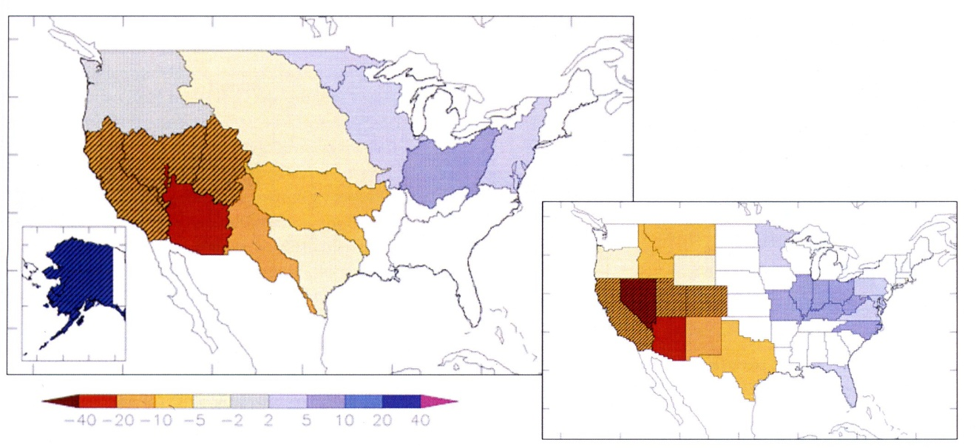
Figure 10. The projected change in annual runoff at 2050 based on the global climate models simulations subjected to a business-as-usual scenario for the greenhouse gas emissions as part of the IPCC Fourth Assessment (based on the published results of Milly et al. 2005). Areas of projected runoff increase (decrease) shown in blue (orange) shades. Shading denotes % change in annual runoff at 2050 relative to 20th Century conditions.

References and Further Reading

Bluemle, J.P., 1991, Radiocarbon dating of beaches and outlets of Devils Lake: North Dakota Geological Survey Miscellaneous Series 75, 10 p.

CCSP (Climate Change Science Program), 2008: Weather and Climate Extremes in a Changing Climate: Regions of Focus: North America, Hawaii, Caribbean, and U.S. Pacific Islands. [Karl, T.R., G.A. Meehl, C.D. Miller, S.J. Hassol, A.M. Waple, and W. L. Murray (eds.)]. Synthesis and Assessment Product 3.3, U. S. Climate Change Science Program, Washington D. C., 164 pp.

Chen, M., W. Shi, P. Xie, V. B. S. Silva, V. E. Kousky, R. Wayne Higgins, and J. E. Janowiak (2008), Assessing objective techniques for gauge-based analyses of global daily precipitation, J. Geophys. Res., 113, D04110, doi:10.1029/2007JD009132.
Data available at :
http://www.cpc.noaa.gov/products/precip/realtime/retro.shtml

Global Climate Change Impacts in the United States, Thomas R. Karl, Jerry M. Melillo, and Thomas C. Peterson, (eds.). Cambridge University Press, 2009.

IPCC (Intergovernmental Panel on Climate Change) 2007: Climate Change 2007: The Physical Science Basis: Contribution of Working Group I to the Fourth Assessment Report (AR4) of the Intergovernmental Panel on Climate Change [Solomon, S., D. Qin, M. Manning, Z. Chen, M. Marquis, K. B. Averyt, M. Tignor, and H. L. Miller (eds)]. Cambridge University Press, Cambridge, UK, and New York, 996 pp http://www.ipcc.ch.
Model data used to construct the red curve of Figure 2 available at
http://www-pcmdi.llnl.gov/sitemap.php

Milly, P.C.D., Dunne, K.A., and Vecchia, A.V., 2005, Global pattern of trends in streamflow and water availability in a changing climate: Nature, v. 438, no. 7066, p. 347-350

Murphy, E.C., Fritz, A.K., and Fleming, R.F., 1997, The Jerusalem and Tolna outlets in the Devils Lake Basin, North Dakota: North Dakota Geological Survey Report of Investigation No. 100, 36 p.

Thornthwaite, C. W., 1948: An approach toward a rational classification of climate. Geographical Review, v. 38, p. 55-94.

U. Schneider, T. Fuchs, A. Meyer-Christoffer and B. Rudolf (2008): Global Precipitation Analysis Products of the GPCC. Global Precipitation Climatology Centre (GPCC), DWD, Internet Publikation, 1-12. (pdf 1414 KB ). Updated version of Rudolf, B. (2005): Global Precipitation Analysis Products of the GPCC. Data available at http://www.esrl.noaa.gov/psd/data/gridded/data.gpcc.html

Vecchia, A.V., 2008, Climate simulation and flood risk analysis for 2008-40 for Devils Lake, North Dakota: U.S. Geological Survey Scientific Investigations Report 2008-5011, 28 p. -- URL http://pubs.er.usgs.gov/usgspubs/sir/sir20085011.

Wiche, G.J.; Vecchia, A.V.; Osborne, Leon; Wood, C.M.; Fay, J.T., 2000, Climatology, hydrology, and simulation of an emergency outlet, Devils Lake Basin, North Dakota: U.S. Geological Survey Water-Resources Investigations Report 00-4174, 16 p. -- URL http://nd.water.usgs.gov/pubs/wri/wri004174/index.html.

